Installation and Activation Guide for Turnitin Schools, Educators, and Students

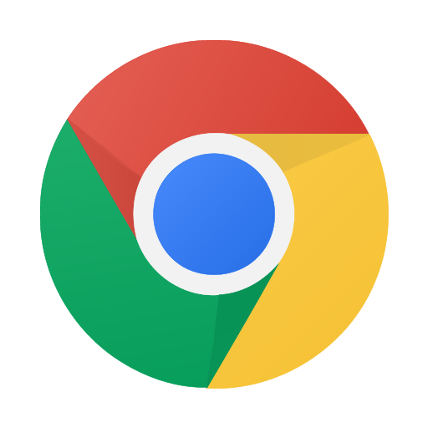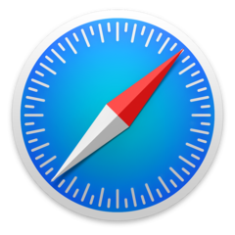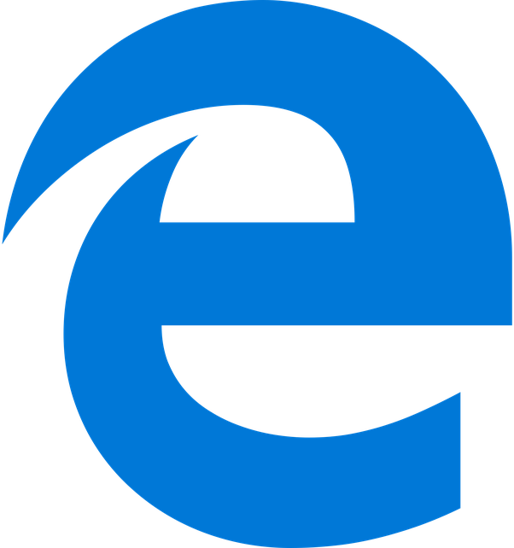

Turnitin and NewsGuard have partnered to grant all students and employees at Turnitin partner schools access to NewsGuard’s digital literacy tools, which provide users with access to trust ratings for thousands of news and information sites. For more information about NewsGuard, visit www.turnitin.com/partners/newsguard.

NewsGuard offers a browser extension for all major browsers: Google Chrome, Microsoft Edge, Apple Safari, and Mozilla Firefox.

NewsGuard also offers a mobile app for the iOS operating system (used by Apple iPhones and iPads) and the Android operating system.

In order to use NewsGuard on a student’s or teacher’s device, there are two necessary steps:

- Install NewsGuard’s browser extension or mobile app on each device
- Activate NewsGuard on the device using the school’s Access Code

These steps can be taken individually by each student, can be done on students’ behalf by an instructor, or can be deployed in bulk on school-managed devices by an IT administrator. The partnership between Turnitin and NewsGuard allows students and staff at Turnitin schools to use NewsGuard on both school devices and personal devices, with no limitations on the number of devices, through the end of the year.

This Installation Guide summarizes the various options for installing and activating NewsGuard on students’ devices.
Table of Contents

Before You Start 3
Installing NewsGuard on a Single Computer 4
Activating NewsGuard on A Single Computer 5
Installing and Activating NewsGuard on a Mobile Device 6
Installing and Activating NewsGuard with GSuite for Education 7
Installing and Activating NewsGuard on Many Computers 10
FAQs: Data and Privacy 12

Before You Start

Before installing and activating NewsGuard, we recommend completing the following steps:

- Get your school’s Access Code for NewsGuard:

Turnitin has emailed the access code to the Turnitin account administrator at your school. Please follow up with your Turnitin representative for any questions.

- Determine which approach to installing and activating NewsGuard works best for your school:

- If many of your students and staff use their own personal devices at school, or if you want to allow students to use NewsGuard on personal devices at home, distribute the instructions for installing and activating NewsGuard on a single computer or mobile device (Pages 4-6).
- If you manage devices for students and staff using cloud-managed browsers in GSuite for Education, follow the steps on Pages 7-9.
- If you wish to install NewsGuard on PC, Mac, or Linux computers managed by your institution, consider using the instructions on Pages 10-11.

- If you plan to have students or educators each activate NewsGuard on their own computer, consider distributing an Easy Activation Link to make things easier.

Part of the process of activating NewsGuard involves going to a page and typing in your school’s access code. To make things easier for students or educators, you can circumvent this step by having each user click a link instead:

https://account.newsguardtech.com/redeem?code=#######

Replace ####### in the above link with your school’s code. For example, if your school’s Access Code is 1HA8HNT5EAK3R0JH97, your Easy Activation Link would be:

https://account.newsguardtech.com/redeem?code=1HA8HNT5EAK3R0JH97

Installing NewsGuard on a Single Computer

Step 1: Find the NewsGuard Listing in Your Browser’s Extension Store: Use the appropriate link for your browser:
- NewsGuard for Google Chrome
- NewsGuard for Apple Safari
- NewsGuard for Microsoft Edge (New)
- NewsGuard for Microsoft Edge (Legacy)
- NewsGuard for Mozilla Firefox

Not sure which browser you’re using? Visit newsguardtech.com/turnitin and click “Get NewsGuard.” We’ll detect which browser you are using and send you to the proper extension store listing.

Step 2: Add NewsGuard to Your Browser: Follow these instructions for how to add NewsGuard on each supported browser:
- For Google Chrome, Mozilla Firefox, and Microsoft Edge (New): Click the blue button labeled “Add to Browser” or “Get”, then click “Add Extension” when prompted.
- For Microsoft Edge (Legacy): Click the “Install” button at the top right. Once the installation is completed, click “Launch,” and then click “Turn it on” when prompted. (If you are asked to sign in to Microsoft, you do not need to sign in. Simply close the dialog to continue installing NewsGuard.)
- For Apple Safari: Click the “Get” button at the top right. Once NewsGuard is installed, the button will change to say, “Open.” Click the “Open” button and follow the instructions in the dialog box that appears.

Activating NewsGuard on A Single Computer

Once NewsGuard is installed, you’ll need to apply your school’s Access Code to enable free access. Follow these instructions to do so:

Step 1: Visit newsguardtech.com/code.

Step 2: Submit your school’s code: Type or copy-and-paste your school’s code into the code field, then click “Redeem” to submit it.

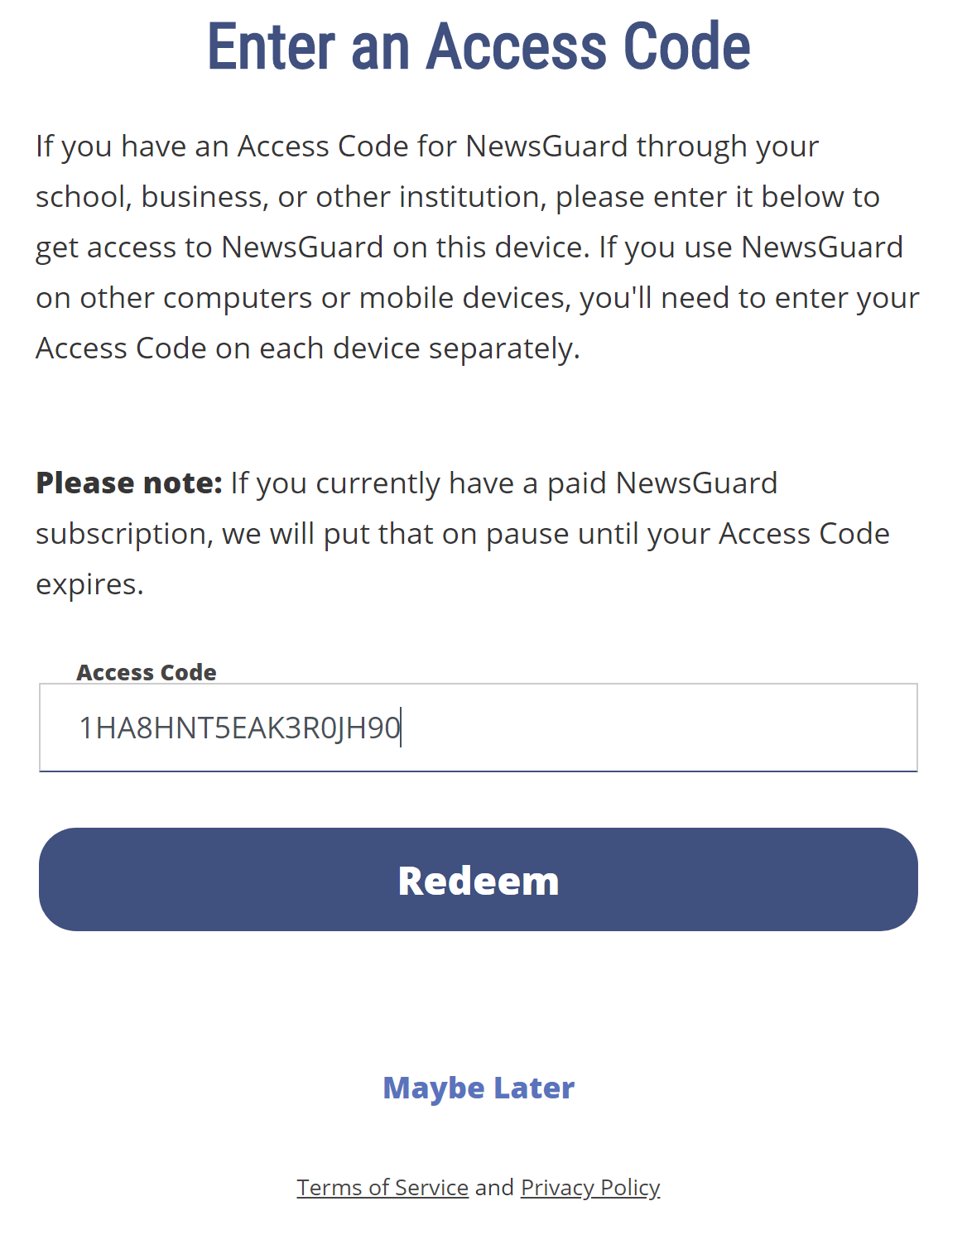
Make Things Easier: To avoid students or teachers having to complete Step 2, you can instead send everyone an Easy Activation Link that automatically activates their NewsGuard access when they click it. Use the following link instructions:

https://account.newsguardtech.com/redeem?code=#######

Replace ####### in the above link with your school’s code. For example, if your school’s Access Code is 1HA8HNT5EAK3R0JH97, your Easy Activation Link would be:

https://account.newsguardtech.com/redeem?code=1HA8HNT5EAK3R0JH97

Installing and Activating NewsGuard on a Mobile Device

Step 1: Install NewsGuard on Your Mobile Device: On an Android or Apple mobile device, search for NewsGuard in the App Store or Google Play Store and open the listing for NewsGuard. You can go directly to NewsGuard’s listing by clicking these links on a mobile device:
- NewsGuard for Android
- NewsGuard for iOS
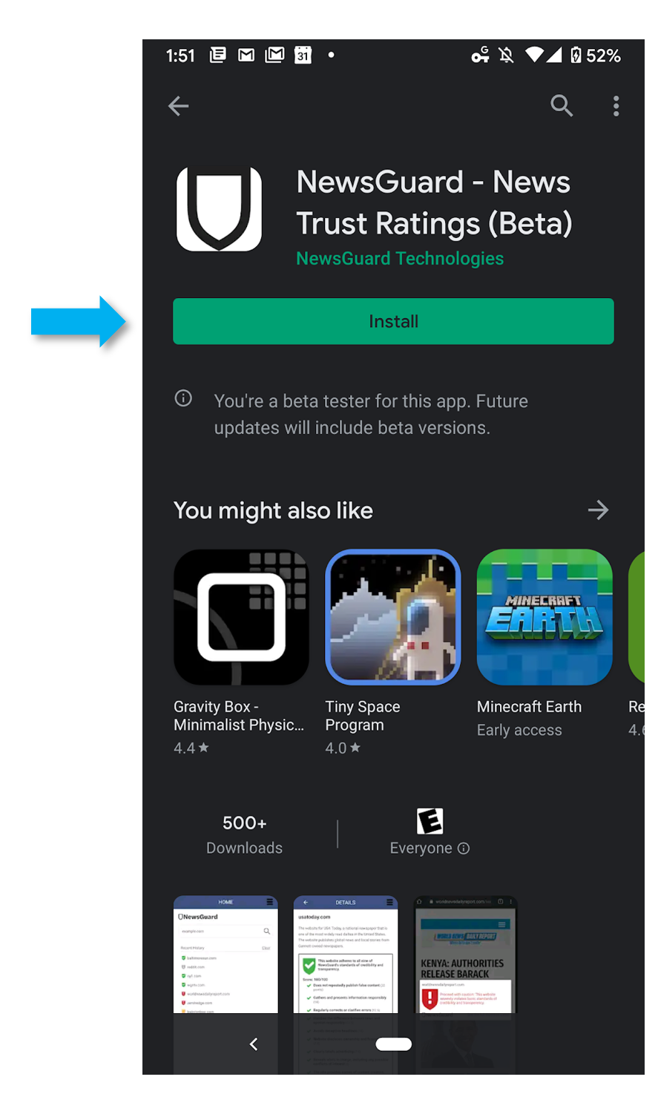

Tap “Install” or “Get” to install NewsGuard on your device.

Step 2: Open the NewsGuard App: Open the NewsGuard app on your device and swipe through the three instruction screens.

Step 3: Enter Your School’s Access Code: When you reach the login page, tap “I have an Access Code.” Type or copy-and-paste your school’s Access Code into the field provided, then tap “Redeem” to submit the code.

Installing and Activating NewsGuard with GSuite for Education

For school systems or universities using GSuite for Education to administer managed Chrome browsers, Chromebooks, or Android devices, NewsGuard can be deployed centrally using the Google Admin tool following the instructions below.

The options described here must be completed by a GSuite for Education account with full administrator privileges.

For Cloud-Managed Chrome Browsers:

Click here for the official Google documentation for this process, or use our more detailed instructions below.

Step 1: Navigate to the Managed Chrome Browsers Page in Google Admin: To get to this page, open the Google Admin console, click on “Devices,” then click “Chrome Management” in the sidebar on the top left.

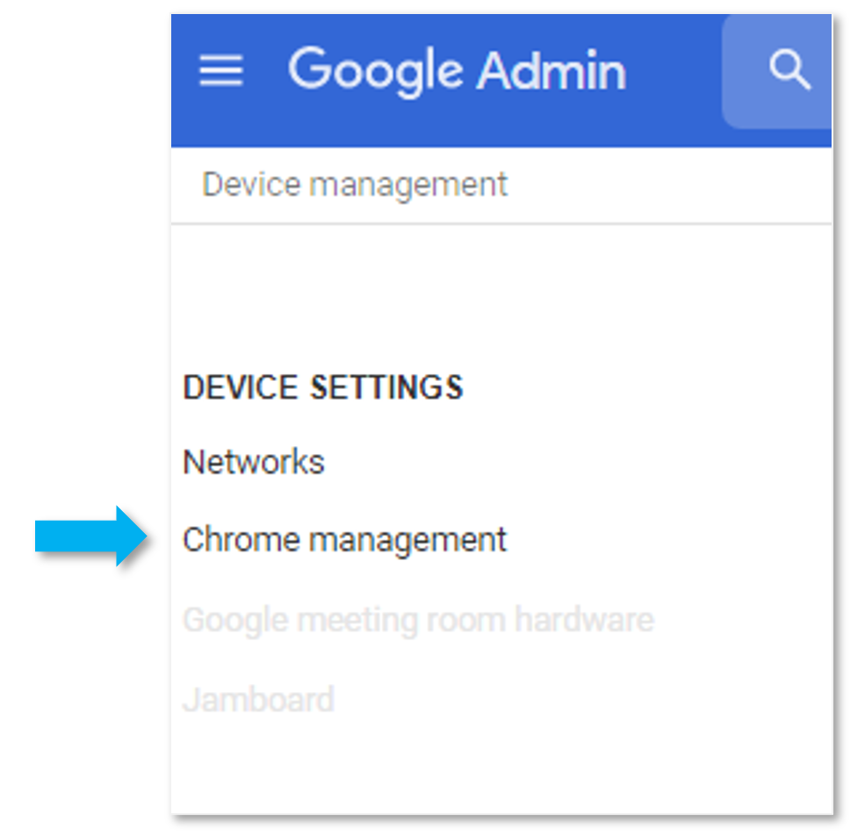

Step 2: Navigate to the Apps & Extension Page: Click the link for “Apps and Extensions” in the center of the page.

Step 3: Add NewsGuard from the Chrome Web Store: Hover over the yellow button in the bottom right, then select “Add from Chrome Web Store.”
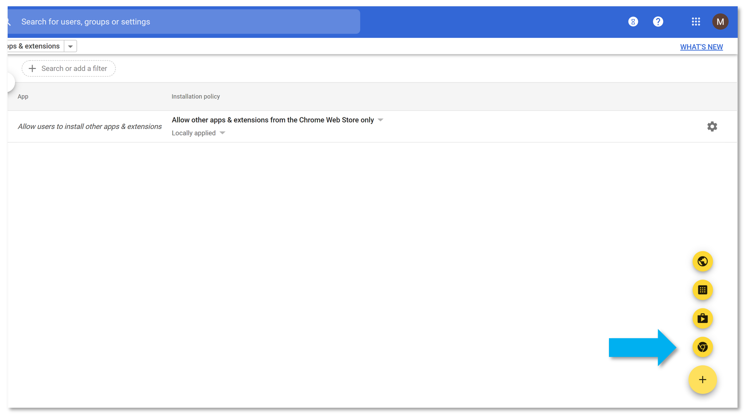

Search for NewsGuard in the search box that comes up, then click “Select” on the NewsGuard extension:

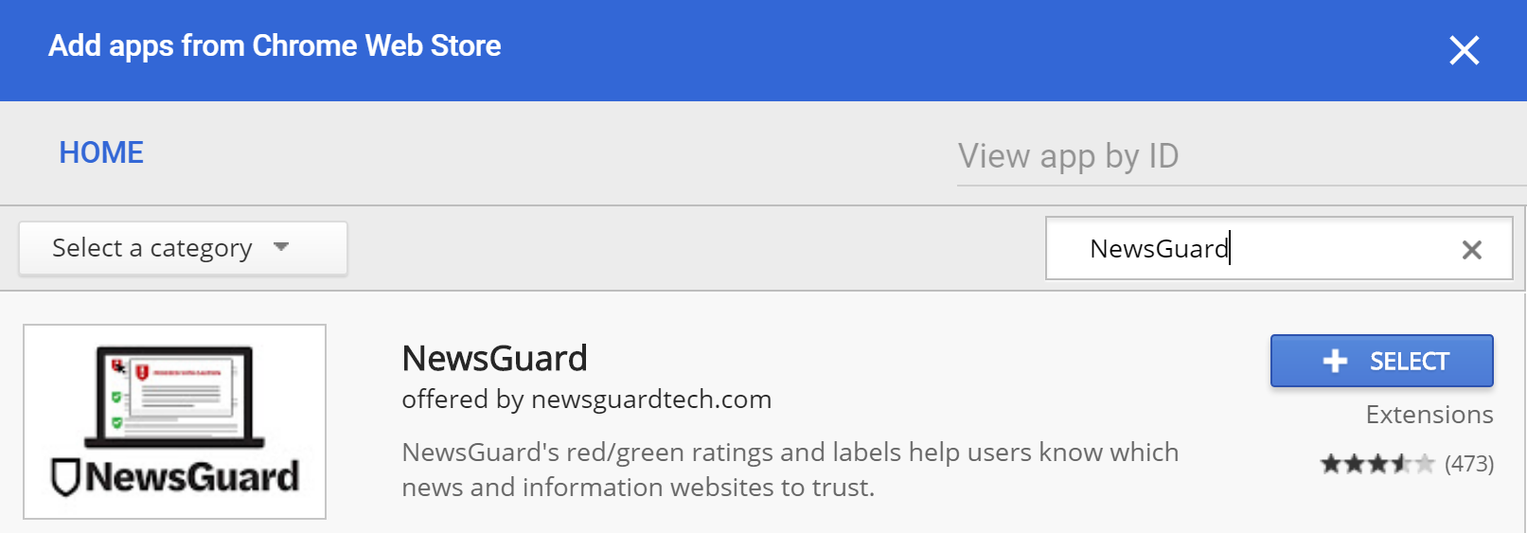

Step 4: Set NewsGuard to Force Install on Managed Chrome Browsers: Click the drop-down arrow to the right of NewsGuard in the list of extensions and choose “Force Install and Pin.”

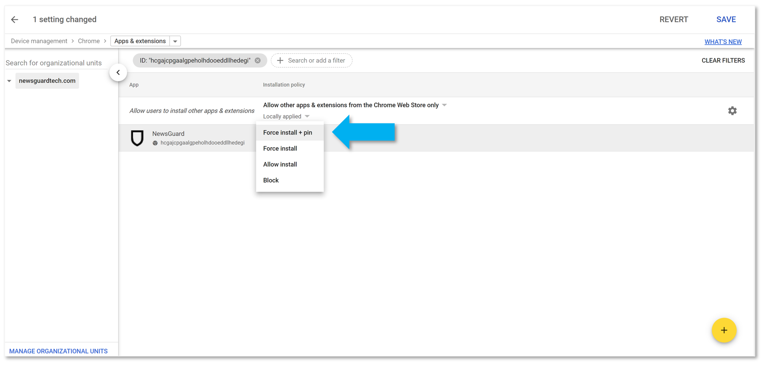

Then click “Save” in the top right corner to apply the changes.

Step 5: Instruct users to activate NewsGuard using your school’s Access Code or an Easy Activation Link. See instructions on Page 5 of this guide.

For Mobile Devices Using GSuite for Education:

Step 1: Add NewsGuard to your organization’s App Whitelist: Follow these instructions from Google.

Step 2: Distribute NewsGuard to whichever devices you choose: Follow these instructions from Google. Note that you may choose to automatically install NewsGuard just for members of a particular Google Group in your organization, or to an entire Organizational Unit. You also may choose whether or not to prevent users from uninstalling the app.

Step 3: Instruct users to activate NewsGuard using your school’s Access Code. Follow the instructions on Page 5 of this document.

Installing and Activating NewsGuard on Many Computers

Deploying NewsGuard Using a Device Image:

If you are configuring multiple computers by creating a device image, you can choose two options:
- Install NewsGuard on the machine from which you are creating the image, then have users activate the Access Code individually. NewsGuard can either be installed manually on the image device (see instructions on Page 4) or using a deployment script (see instructions below). Users can activate the Access Code by entering it manually using the instructions on Page 5 of this guide or by clicking an Easy Activation Link (also described on Page 5).
- Install and Activate NewsGuard on the machine from which you are creating the image. This option will bypass the need for an end-user to activate NewsGuard on each device using their school’s Access Code.
  - To activate NewsGuard on the image machine, either manually follow the steps on Page 5 of this document when configuring the image or include a command in your device configuration script to open the Easy Activation Link, replacing ####### with your school’s Access Code. https://account.newsguardtech.com/redeem?code=#######

Deploying NewsGuard Using a Group Policy Editor or Deployment Script:

School IT administrators can script an installation of NewsGuard on many devices at once using deployment scripts.

Installing NewsGuard Using a Deployment Script

To script an offline installation of the browser extension, you will need the extension ID and the update URL of the Chrome extension.

The following links should provide helpful instructions for writing deployment scripts for browser extensions: (link 1, link 2, link 3, link 4, link 5, link 6).

See below brief instructions for offline installations on Chrome, Firefox, and Edge, along with the extension ID and update URL for each browser.

Chrome:
- Computer Configuration > Policies > Administrative Templates > Google > Chrome > Extensions
- Edit, Configure the list of force-installed apps and extensions
- Extension ID: hcgajcpgaalgpeholhdooeddllhedegi
- Update URL: http://clients2.google.com/service/update2/crx?response=updatecheck&x=id%hcgajcpgaalgpeholhdooeddllhedegi

Firefox:
- Computer Configuration > Policies > Administrative Templates > Mozilla > Firefox > Extensions
- Edit, Extensions to install
- https://addons.mozilla.org/firefox/downloads/file/3467314/newsguard-1.6.8-fx.xpi

Edge\IE:
- Computer Configuration > Policies > Administrative Templates > Windows Components > Internet Explorer > Security Features > Add-on Management
- Edit, Add-on List
- {325232C3-3D82-4FBC-8C50-658345E8D510} VALUE:2

Activating NewsGuard Using a Deployment Script or Group Policy EDitor

There are two options for activating NewsGuard if you have installed the extension using a deployment script or group policy editor:

- Instruct users to activate NewsGuard on each device: If you would prefer to have each user activate NewsGuard on the devices they use, they can do so by entering your school’s Access Code at www.newsguardtech.com/code or by distributing an Easy Activation Link. Use the instructions on Page 5 of this guide to do so.
- Activate NewsGuard during a scripted installation: Include a command in your deployment script that opens an Easy Activation Link URL in each browser that has NewsGuard installed. The Easy Activation Link URL is below. Replace ####### with your school’s Access Code.
https://account.newsguardtech.com/redeem?code=#######

FAQs: Data and Privacy

1. Why does NewsGuard's browser extension ask for permission to read and modify web page contents?

NewsGuard's browser extension requires users to grant it access to read and modify web page contents and data as the user browses websites. This permission is required because NewsGuard's software reads the HTML code of certain pages--such as Google and Bing search results, Twitter feeds, Facebook feeds, Reddit pages--and looks for links to news websites. If NewsGuard has rated a site linked on those pages, the extension inserts a red or green shield icon next to the link, indicating NewsGuard's rating for the site. In order to do this, NewsGuard's extension must have the ability to read and modify web pages. This is the only purpose for which we use this permission. Other popular browser extensions, such as the shopping app Honey and the web security app Web of Trust, require similar permissions for similar reasons.

2. Does NewsGuard collect, store, or share data about its users?

NewsGuard does not collect any personally identifiable information about users accessing NewsGuard through Turnitin, nor does it sell or share any data about its users with any third party. When a user installs NewsGuard's browser extension, NewsGuard is only able to collect anonymous usage information through the use of Google Analytics.

However, NewsGuard does not store any information--even anonymous information--about what websites users have visited or their browsing history. When a user visits a website with NewsGuard's extension installed, the browser extension sends the website domain to NewsGuard’s servers to check whether a rating and nutrition label exists for that site and, if one does, to display that rating and nutrition label in the user's browser. However, NewsGuard does not collect or store this information or any information about the websites the user has visited. The servers and load balancers that receive this information do not store or transmit any logs of this traffic. NewsGuard cannot and does not use data about the websites users visit for any purpose other than to serve its ratings and nutrition labels to users.

