GUIDE FOR STUDENTS USING NEWSGUARD
NEWSGUARD’S CRITERIA
What is NewsGuard?
NewsGuard helps people build media literacy skills, avoid misinformation, and conduct online research with confidence. NewsGuard’s trained journalists rate and review thousands of news and information websites to help users know which sites they can generally trust – and which might be trying to deceive them. These ratings can be accessed from NewsGuard’s desktop browser extension or mobile apps.
How does NewsGuard review websites?
Each site is rated using nine standards of credibility and transparency. Based on how the site fares on the nine criteria, it receives a score out of 100, which corresponds to an overall Red rating (for sites receiving fewer than 60 points) or Green rating (for sites receiving 60 or more). Each site also receives a full “Nutrition Label” review that explains each rating and discusses the site’s ownership, financing, content, credibility, transparency, and history. Read a Nutrition Label and you can see exactly how and why NewsGuard rated a site the way it did.
When and how should I use NewsGuard?
NewsGuard’s ratings can be helpful any time you are browsing online, but they are particularly useful for…
- Scrolling through social media (like Twitter and Facebook)
GREEN AND RED RATINGS
This website generally adheres to basic standards of credibility and transparency
This website generally fails to adhere to basic standards of credibility and transparency
- Using a search engine (like Google or Bing)
- Conducting online research for a paper or project
These ratings and Nutrition Label reviews can help you understand whether a site is highly trustworthy, whether it has some issues, or whether it is completely unreliable. But ultimately, you should always assess each site for yourself, thinking critically about how much to trust it.

Installing the NewsGuard browser extension
THE BROWSER EXTENSON
Install the extension for Chrome, Edge, Firefox, or Safari by following the link for your browser:
- Google Chrome: http://bit.ly/2mMUEKj
- Microsoft Edge: http://bit.ly/2N0ASX6
- Mozilla Firefox: http://mzl.la/2x4rE5w
- Apple Safari: https://apple.co/2pPR8jJ

Using the Extension: What you will see
Once you install NewsGuard’s browser extension, NewsGuard rating icons will begin to appear next to links on search engines and social media feeds, including Facebook, Twitter, Google, and Bing. Ratings also appear in the upper-right corner of websites rated by NewsGuard, next to the URL bar.
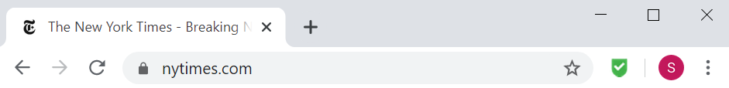

Using the extension: Interacting with the extension
- NewsGuard ratings will appear next to website links on social media or search results.

- Hover over each icon to see a brief description of the site and why it received its rating.

- To see the full rating of each website, click, “See the full Nutrition Label.” Each Nutrition Label describes the website’s background, ownership, and why it received its rating–including its performance on each of the nine criteria:
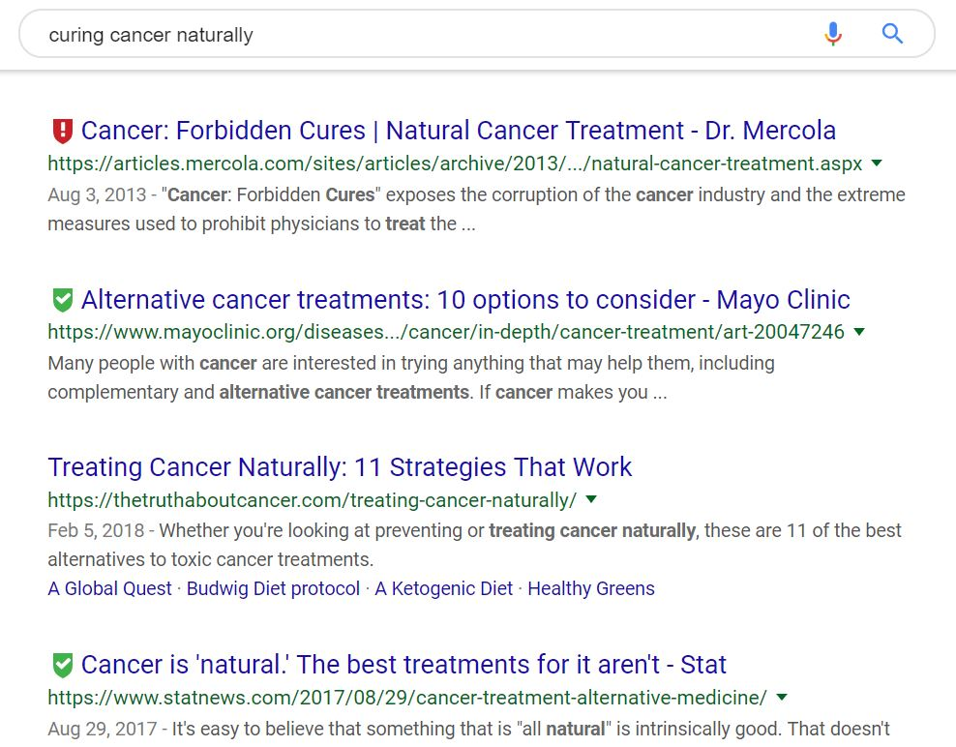
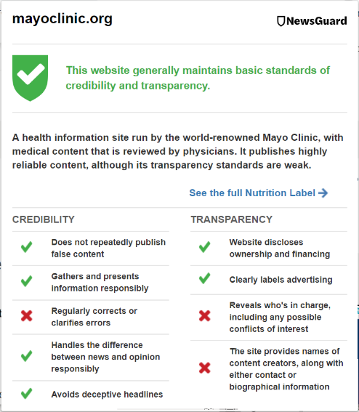
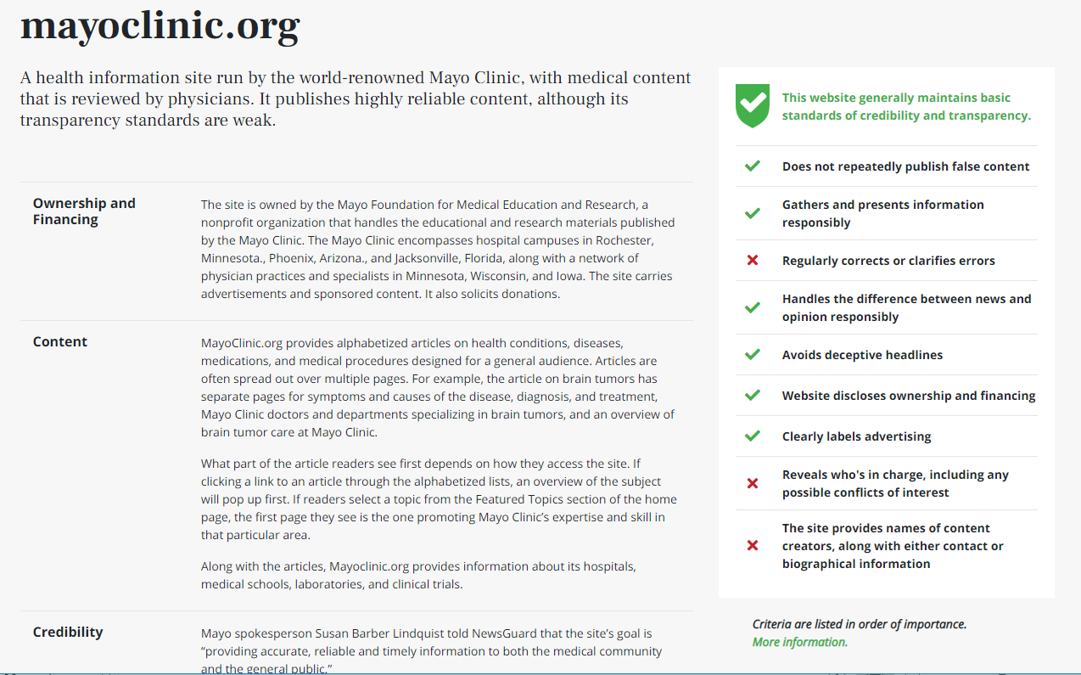
HOVER OVER THE ICONS TO LEARN MORE ABOUT EACH SITE
CLICK TO READ THE SITE’S FULL NUTRITION LABEL REVIEW

THE ICONS
UNDERSTANDING THE TWO MAIN NEWSGUARD ICONS:

Proceed with caution: This website fails to meet several basic standards of credibility and transparency. | A site with a red badge lacks credibility or transparency in important areas and should generally not be trusted as the primary source of information. Users should always independently verify information on red sites, and if they feel there is a compelling case for citing a red site, they should be able to clearly articulate why.
This website generally maintains basic standards of credibility and transparency.  ADDITIONAL ICONS: | A site with a green badge can generally be trusted, but not all sites rated green are equal. A green site may still lack credibility or transparency in certain key areas. Users should read the full Nutrition Label to understand any shortcomings of the site that might impact whether they should trust its information.
This is a satire or humor website. It is not an actual news source. | A website intended to entertain. Unlike a false news website that is intentionally deceiving, a satirical website is upfront about its nature, or widely known to be a parody. A common example is The Onion. Much like a red website, an orange website should typically not be consulted as the primary source of information, unless there is a compelling reason for citing it.
This website is a platform that publishes content from its users that it does not vet. Information from this source may not be reliable. | A platform, such as Wikipedia or YouTube, where users produce content that might not be edited or vetted for accuracy. Readers should independently verify information on the platform using reputable sources.
(or no badge displayed)  This website is still in the process of being rated by NewsGuard. | Stay tuned: NewsGuard’s team of journalists is currently in the process of reviewing this website.
 | When a white badge appears next to the URL bar of a website, or no badge appears next to a link on social media or in search results, it indicates that NewsGuard has not rated the site and does not plan to rate it soon. This does not mean that it isn’t a reliable source; it likely means that the website is not a typical news website, or that it does not have a large enough reach for NewsGuard to consider rating it.
CREDIBILITY
THE NINE CRITERIA

False Content: | Does the site repeatedly publish false content? While many websites occasionally make mistakes, sites that do not promptly correct those errors may be trying to misinform readers. False stories can range from political conspiracy theories to health myths.
Gathering & Presenting: | Does the site gather and present information responsibly? Gathering information responsibly involves referencing multiple sources, preferably those that present firsthand information on a subject. Presenting information responsibly means providing a balanced, fair account of events – not misstating facts, misquoting sources, or distorting information by only including certain facts while leaving out other key details.
Corrections: | Does the site regularly correct errors? Even the most reliable news organizations sometimes make mistakes, but credible news outlets should have a policy for routinely correcting their errors and transparently communicating those corrections to readers – such as by adding a “correction” notice or “editor’s note” to stories.
News vs. Opinion: | Does the site handle the difference between news and opinion responsibly? Some websites only publish opinion stories, and others only publish news reports, but many sites publish a mixture of both. Credible news outlets should make it clear to their readers which stories contain commentary – such as by labeling them “opinion” or publishing them in an opinion section. If a website approaches its reporting from a certain point of view, it should clearly disclose its perspective to readers.
Deceptive Headlines: | Does the site avoid publishing deceptive headlines? A headline tells a reader what is in the story before he or she decides to read it. Some websites use exaggerated headlines that distort the facts in a story to entice people into clicking and reading an article. Deceptive headlines are dangerous because people may only skim headlines they encounter online, and not take the time to read the articles.

TRANSPARENCY

Ownership & Financing: | Does the site disclose its ownership and financing? News organizations may be owned by an individual, a private company, a nonprofit organization, or a government. Transparent sites should clearly tell readers who owns the site and where its money is coming from – especially if the owners or funders have political or ideological motivations.
Advertising: | Does the site clearly label advertising? Sometimes companies will pay to have articles written about them or pay to run ads that look like stories. Transparent sites should make it clear to the reader what content is paid for, and what is independent editorial content.
Who’s in Charge: | Does the site reveal who’s in charge? Sites should clearly identify those in charge of making decisions about reporting and coverage – such as their editor(s) or publisher(s) – so that they can be held accountable for content on their site.
Content Creators: | Does the site identify its content creators? Stories should be attributed to an author, using their real name. The site should also provide contact information for its content creators, so readers can ask questions and make complaints, and bios revealing their backgrounds and any conflicts of interest with what they report.
HOW TO READ A NUTRITION LABEL
THE NUTRITION LABELS

The site’s name and a one or two sentence overview.

Identifies who owns a site and how it makes money.
Ownership & Financing:

Describes the type of stories, videos, and other information on the site. Also explains if the site reflects an ideology.
Content

Explains the site’s reporting practices, describing why NewsGuard passed or failed the site on each of the five credibility criteria.
Credibility

Transparency
The criteria checklist, showing how a site fared on NewsGuard’s nine criteria, its resulting score out of 100, and the overall rating it received (Red or Green).
Explains the site’s transparency practices, describing why NewsGuard passed or failed the site on each of the four transparency criteria.

Provides context for how long a website has been around, why it was started, how it has changed over time.
History

Names the NewsGuard journalists who reviewed this site, linking to their bios and contact info. Also provides a link for feedback on the review.

Sources

A list of source links, organized by section, to support each fact stated in the review.

